**Assignment 2**

By Calabangiu Tudor Teachers

Student Number Dr. Phil Lord

180322435 Dr. Neil Speirs

Email adress: ctudor93@yahoo.com

Out of the given tasks, my code achieves the following:

* Having the 4 classes Sandwich, Bread,Topping,Filling
* It allows the creation of an object for a sandwich, with one kind of bread, several fillings and a sauce or topping
* It has a user interface where the user can create his own sandwich
* It has a class for choosing a predefined sandwich in case the user doesn’t want choose his ingredients

My code doesn’t have a facets as I couldn’t get them to work.

**Testing**

Next I will test different parts of my code to prove that it is working.

First, the sandwichBuild class.

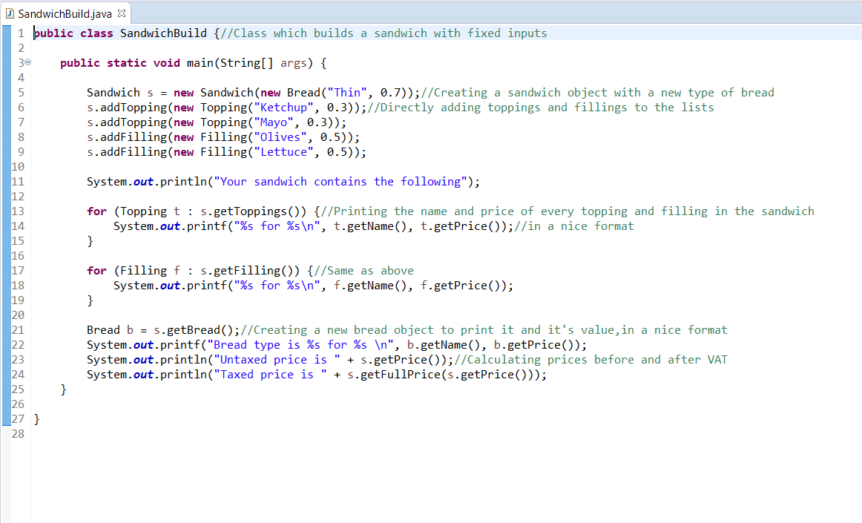

This class takes a sandwich object and directly adds into its fillings and toppings.

I know it works because it properly prints out the names and value of the chosen ingredients and it correctly calculates the price of the sandwich with and without VAT.

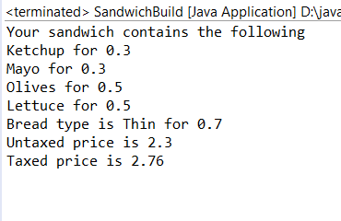

Since the inputs are done inside the code, it can’t be tested further.

Second is the sandwichChoice class.

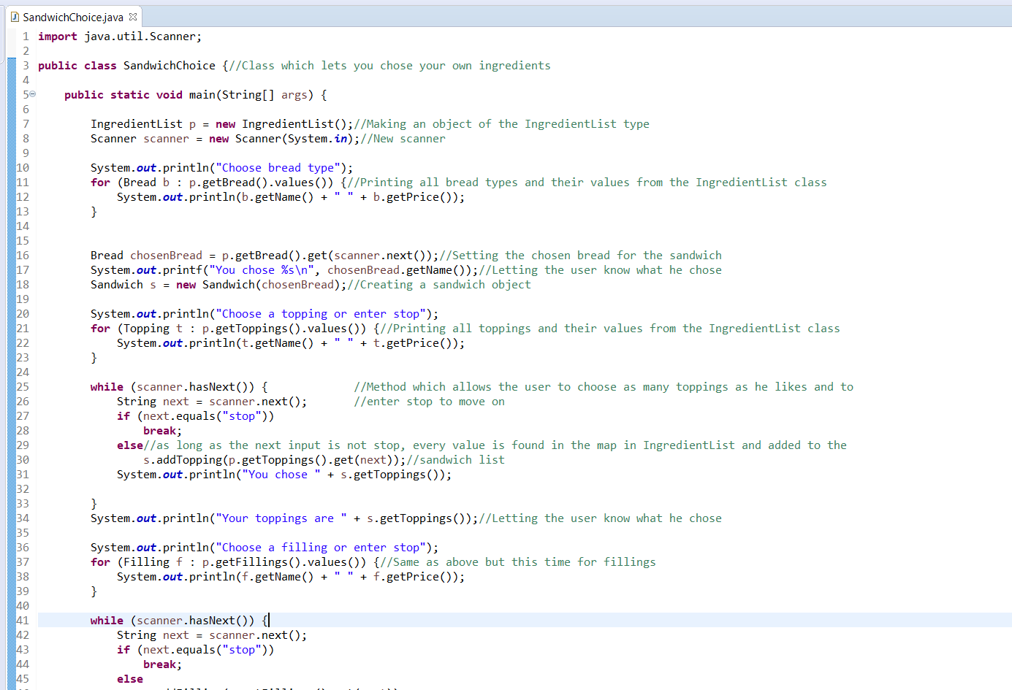

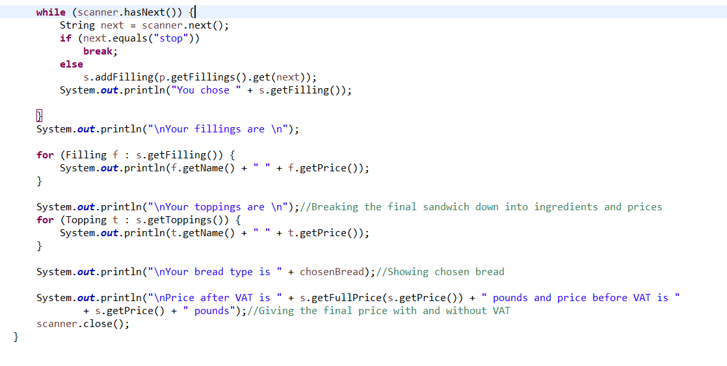

This class works as intended because as long as the names of the ingredients are input properly, it creates a new sandwich without problems.

Here I chose Italian bread as the bread type and 3 toppings.

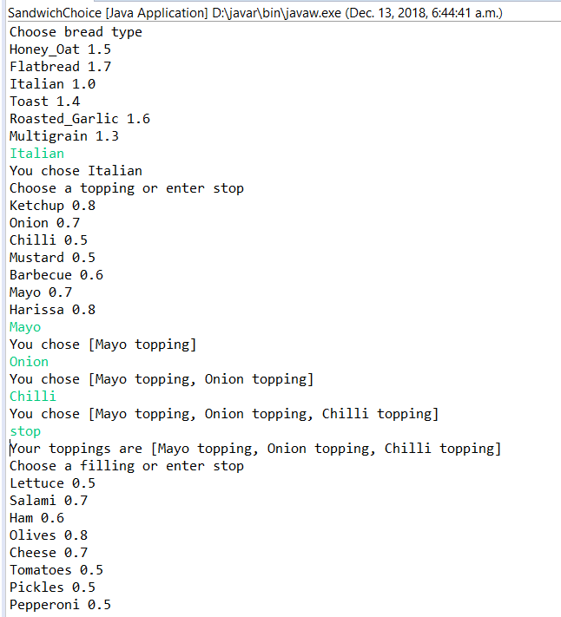

And then I chose 2 more fillings.

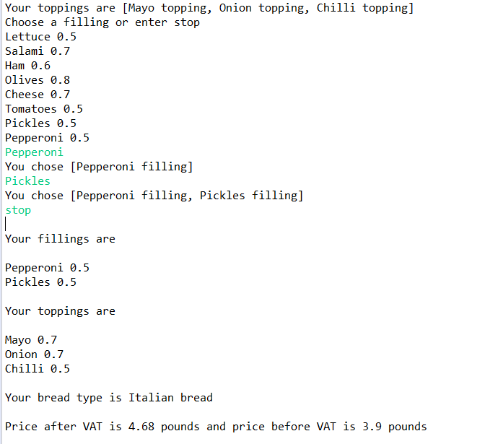

As you can see, it breaks down the ingredient list and price as expected.

The problem is that the inputs have to be case sensitive and a single typo will cause the program to crash at the end because it will register a null value and give a NullPointerException.

Next is the sandwichMenu class which holds the 3 requiered predefined sandwiches for customers who don’t want to create their own sandwich.

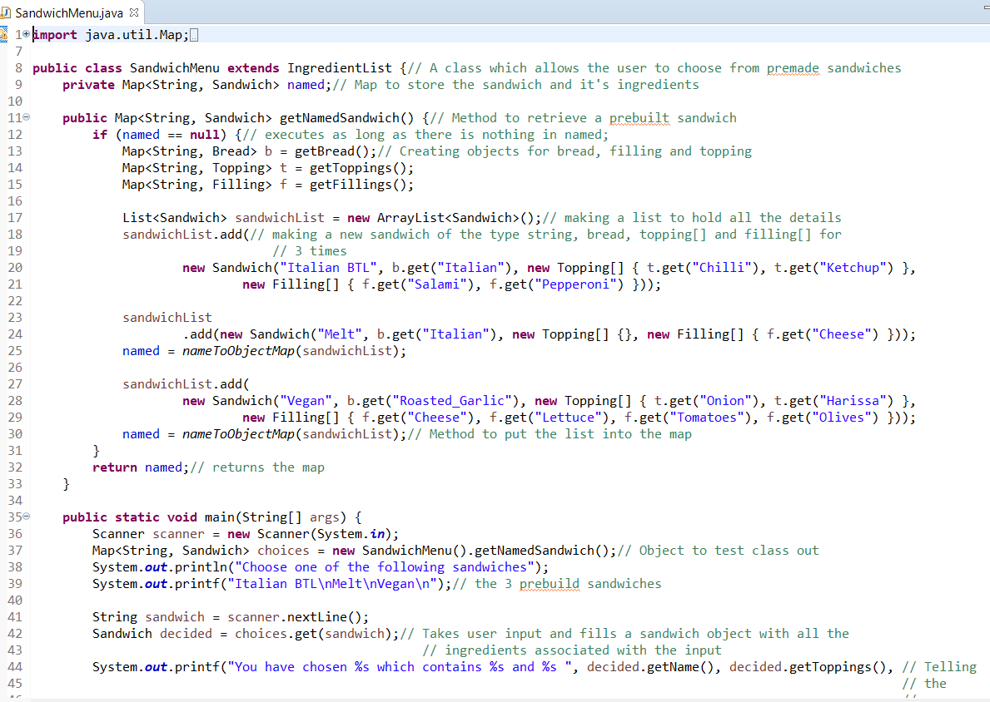

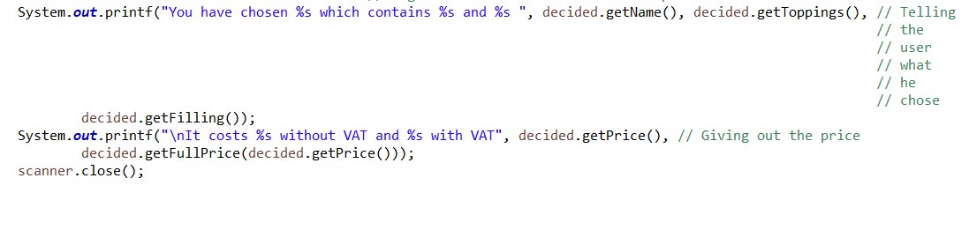

In here I used a sandwich object with 4 inputs and a map to hold all 3 sandwiches

It works as intended because no matter whichever predefined sandwich is entered, the program works as intended and stores all the values associated with the sandwich name the user inputted, into the sandwich class object where they can be accessed with get methods.

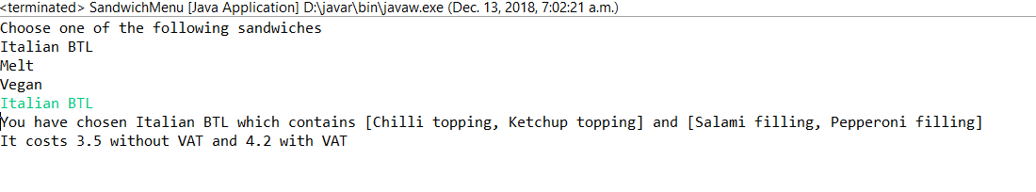

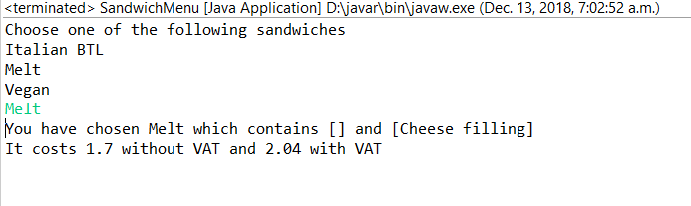

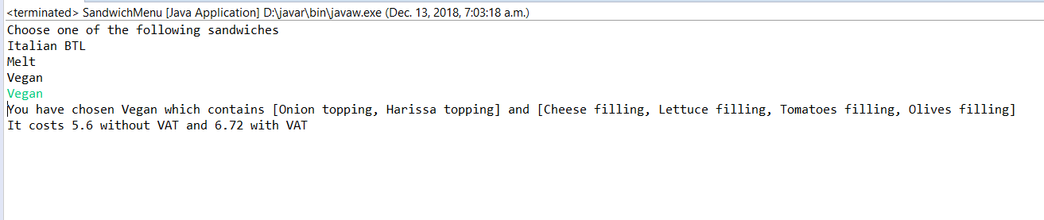

Here is the same problem as in sandwichChoice, user input is case sensitive and typos cause it to crash.

Throughout my assignment I have made use of inheritance between my classes in order to reduce the amount of duplicate code among classes by having subclasses share common code and because I could use overriding to meaningfully implement the code of the base class into the derived classes.